**STEP 1**: Install all needed software “*Git , Tortoise SVN*

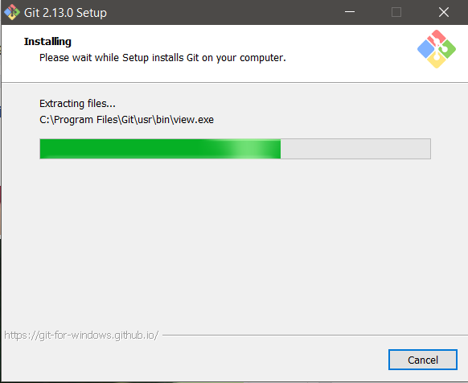Git Installation

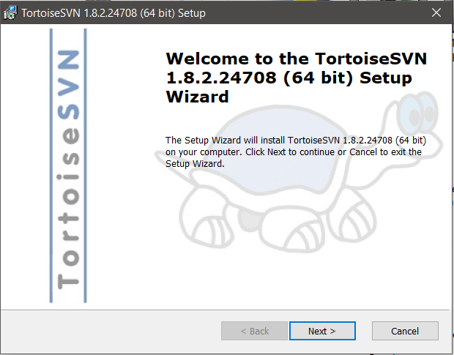Tortoise SVN installation

**Step 2:** Create a folder on your desktop

Name Under your project



Step 3: Login you git account

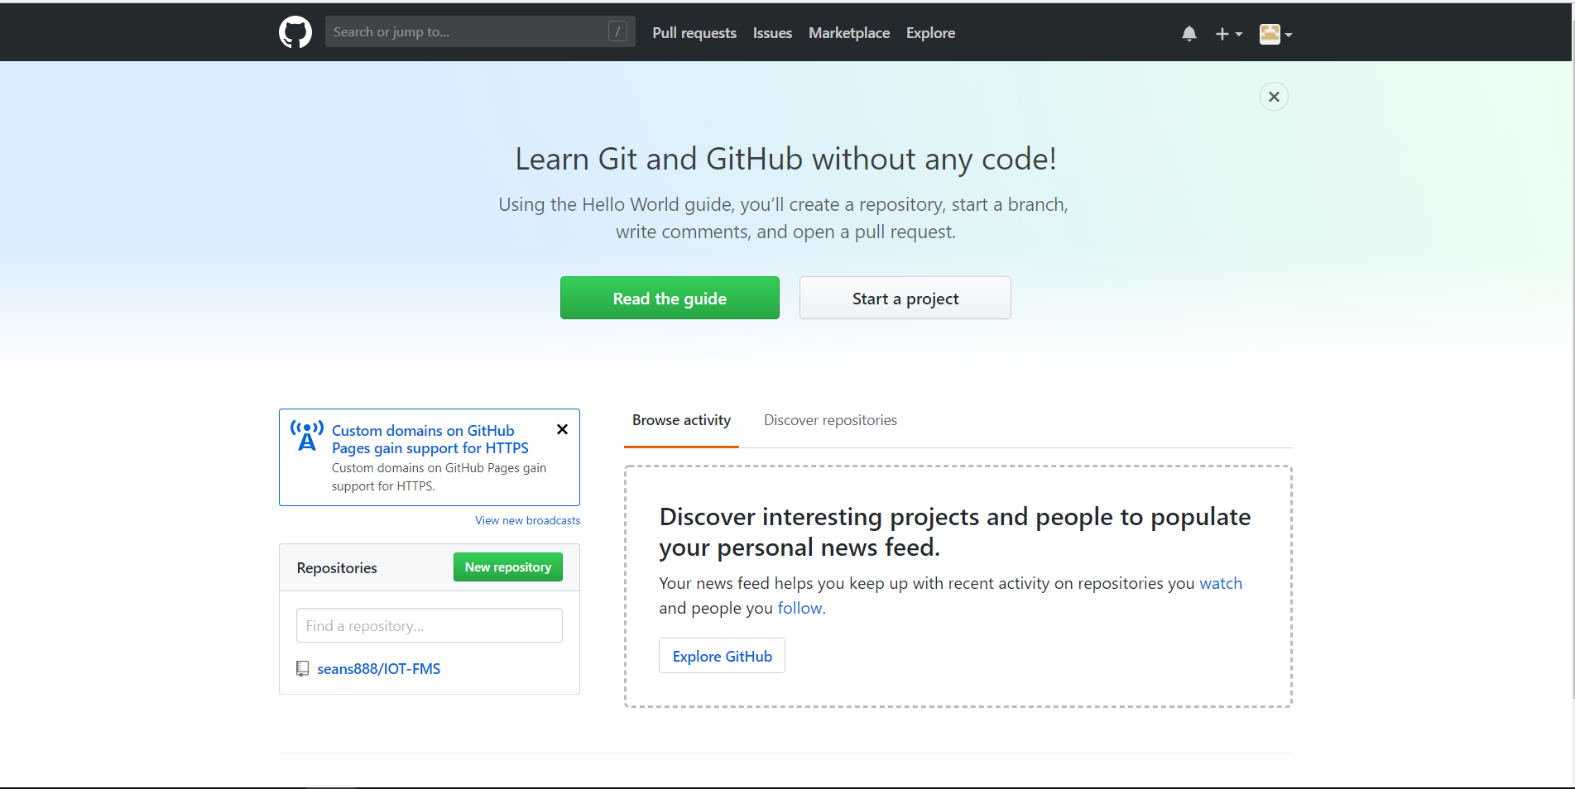

**Step 4:** Click Repository under your project

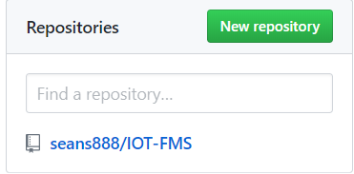

**STEP 5:** Copy full link



**Step 6:** Go to your folder and right click it

Click SVN Checkout

Then go inside trunk

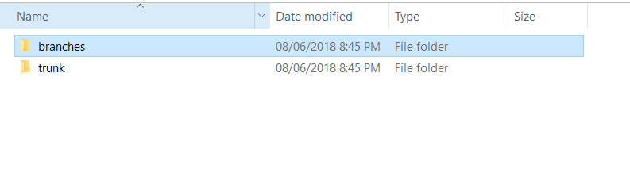

**Step 7:** Create a folder name Documentation

Note: Git will not accept commits if folder is empty so at least put some file

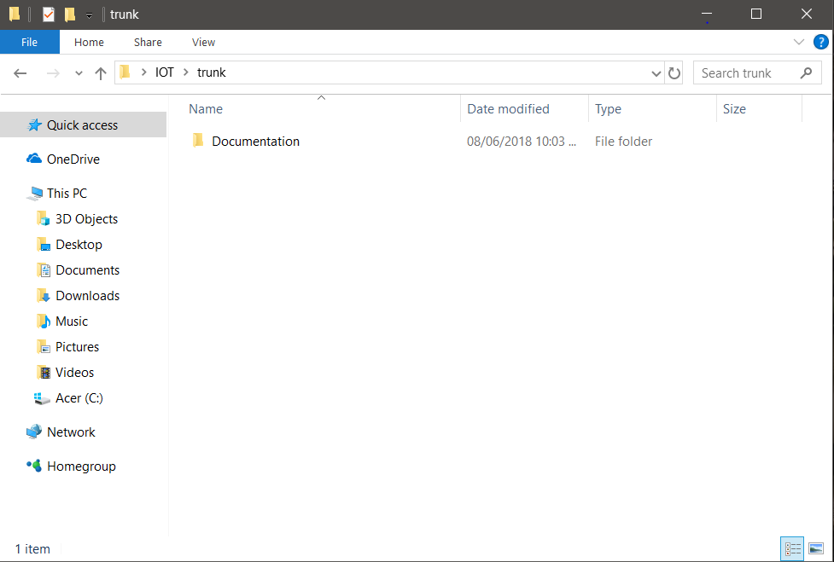

**Step 8:** Add your File

Then right click the whole folder and click commit

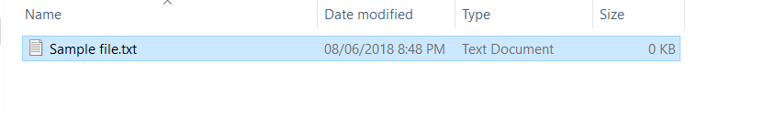

**Step 9**: Then check all file and folders that you recently added

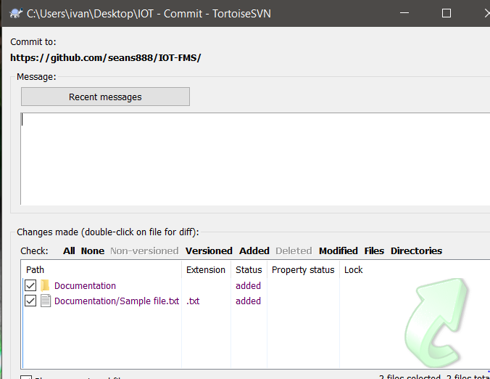

**Step 10:** Input your password

Then you’re done!

Note: If you encountered an error “MKCOL not allowed” it means someone already committed a file with same attributes try updating the folder use SVN update or try renaming your file

To ensure that your file got uploaded you can check it on github

